­­­­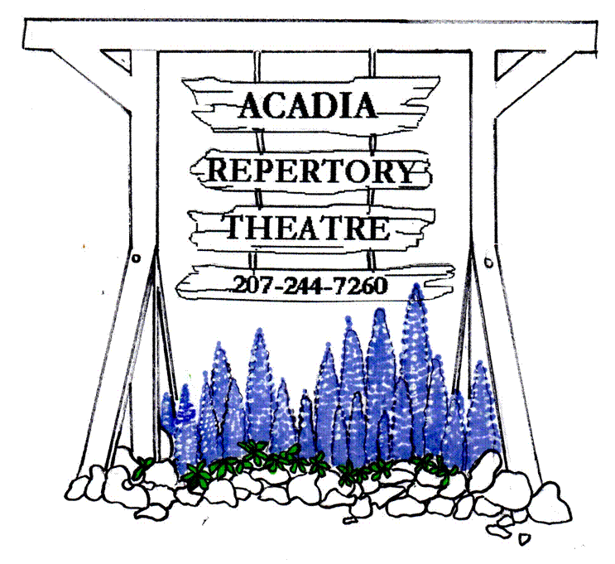

[www.acadiarep.com](http://www.acadiarep.com) Email: art@acadiarep.com

*Live Professional Theatre on Mt. Desert Island*

SOUVENIR **by Stephen Temperly**

**Tuesday June 25 to Sunday July 7**

Sea Marks**by Gardner McKay**

**Tuesday July 9 to Saturday July 20**

**The 39 Steps** **by Patrick Barlow**

**Tuesday July 23 to Sunday August 11**

**Holmes & Watson by Jeffrey Hatcher**

**Tuesday August 13 to Sunday September 1**

**PERFORMANCES**: **TUESDAY** thru **SATURDAY EVENINGS** at **8:00 PM, SUNDAY MATINEES** at **2:00 PM**

**2024 ~ *51st Summer Season!***

Dear friends,

The theatre industry may be in some turmoil nationwide, but here at the Acadia Rep, at age 51, we’re still chugging along like the Little Theatre That Could, thanks to hard-working actors and staff, supportive businesses, and, most especially, many thousands of dedicated audience members like you!

We are again producing our classic four-play summer season this year. First off, we have the wonderful SOUVENIR, featuring the triumphant return of Acadia Rep favorite Cheryl Willis as Florence Foster Jenkins, joined by Bangor’s own Rob Laraway as her accompanist Cosme McMoon. Second, we have the poetic and bittersweet SEA MARKS, a romance set on the coast of Ireland and in Liverpool. Following that, we bring back THE 39 STEPS, a hilarious theatrical send-up of the Alfred Hitchcock film. And finally we have HOLMES AND WATSON, in which Watson is called to an asylum on a remote island off the Scottish coast to determine which of three patients claiming to be Sherlock is the real thing!

We again offer several options for you to subscribe and support the Theatre this year:

* Our classic **Patron** subscription costs a mere $500 for 25 tickets, with greater discounts for larger numbers of tickets!
* Our **Season Subscriptions** will cost $90, which is 25% off the full ticket price – *one show free!*
* And any **Donations** you would care to make beyond that will not only provide us essential support, but may be tax-deductible as a charitable contribution!

It bears reminding that we have cemented this major change to our performance schedule: For all evening performances, THE CURTAIN WILL RISE AT 8:00 PM! Let us repeat:

**THE CURTAIN WILL RISE AT 8:00 PM!!**

(But the Sunday matinees will remain at 2:00.)

Every year that passes increases the challenge of producing a theatre season on an island that has changed so much over the decades. But we persevere, out of love and dedication, and also sheer mulish stubbornness! We look forward to greeting you in Somesville!

*Andrew, Cheryl, and the Board of Directors of the Acadia Repertory Theatre*

Please combine these options as you see fit! Simply buying tickets is enough, but anything you feel you are able to donate is enormously helpful for our work. No donation is too small. The generosity and support of our audience kept us afloat throughout the COVID Years, and like a steady ship finally past the storm, with your continued help, we head full sail towards another 50 years of live theatre on Mount Desert Island!

**ACADIA REPERTORY THEATRE** P.O. Box 106, Mt. Desert, ME 04660

**\**

**NAME: _________________________________________________________________**

**(as you’d like to see it listed in our Program Book and lobby display)**

**\**We only need your address if it has changed since last year!\****

**ADDRESS: _____________________________________________________________**

**CITY: _________________________________STATE: _______ ZIP: _____________**

**E MAIL: ________________________________________**

**PHONE NUMBER: _______________________________**

I/we wish to become a **PATRON** for the 2024 SUMMER SEASON.

PATRON (25 tickets) **$500 (__)** PATRON (50 tickets) **$900­­­___(__)**

PATRON (75 tickets) **$1200___(__)** PATRON (100 tickets) **$1500­­­___(__)**

Please list me/us as a **DONOR** for the 2022 SUMMER SEASON.

*(Donations may be tax-deductible as contributions to a 501.c.3 charitable organization)*

KATAHDIN CIRCLE **$5000+ (__)**

CADILLAC CIRCLE **$2000+ (__)**

SARGENT CIRCLE **$1000+ (__)**

DORR CIRCLE **$500+ (__)**

PEMETIC CIRCLE **$250+ (__)**

CHAMPLAIN CIRCLE **$100+ (__)**

BUBBLES CIRCLE **Any amount (__)**

**ACADIA REPERTORY THEATRE** P.O. Box 106, Mt. Desert, ME 04660

Please list me/us as a **SUBSCRIBER** for the 2024 SUMMER SEASON.

ONE SUBSCRIPTION **$90 (__)**

TWO SUBSCRIPTIONS **$180 (__)**

(____) SUBSCRIPTIONS **@$90 each (_______)**

ADDITIONAL DONATION **Any amount (_­­­______)**

*(Donations may be tax-deductible as contributions to a 501.c.3 charitable organization)*

**NAME: _________________________________________________________________**

**\**We only need your address if it has changed since last year!\****

**ADDRESS: _____________________________________________________________**

**CITY: _________________________________STATE: _______ ZIP: _____________**

**EMAIL: ________________________________________**

**PHONE NUMBER: _______________________________**