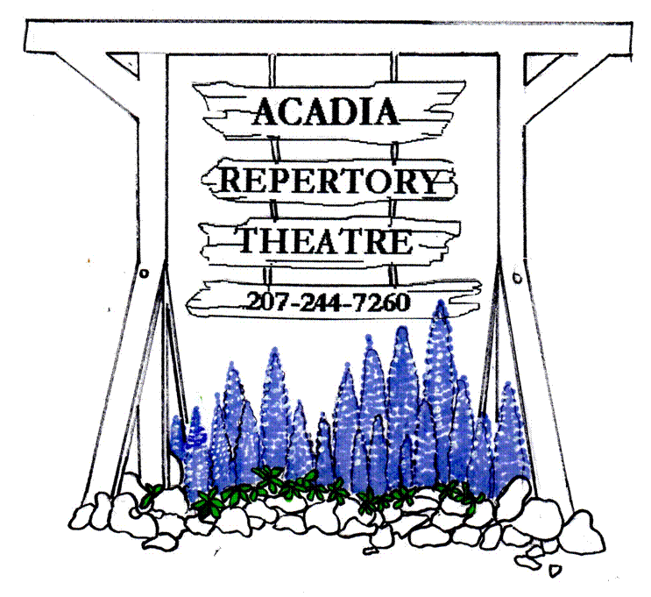
www.acadiarep.com Email: art@acadiarep.com Live Professional Theatre on Mt. Desert Island
Kenneth Stack is Clarence Darrow
David W. Rintels
June 27th to July 9th
A Thin Place
Lucas Hnath
July 11th to July 23rd

Love and Baseball
Jerry Montoya
July 25th to Friday August 11th
Agatha Christie’s The Mousetrap
August 15th to September 3rd
PERFORMANCES: TUESDAY thru SATURDAY EVENINGS at 8:00 PM, SUNDAY MATINEES at 2:00 PM

ACADIA REPERTORY THEATRE P.O. Box 106, Mt. Desert, ME 04660

\

NAME: _________________________________________________________________
(as you’d like to see it listed in our Program Book and lobby display)

*We only need your address if it has changed since last year!*

ADDRESS: _____________________________________________________________
CITY: _________________________________STATE: _______ ZIP: _____________
E MAIL: ________________________________________
PHONE NUMBER: _______________________________

2023 ~ 50th Summer Season
Dear friends,
We are thrilled to return to the Somesville stage for our Special quinquagenarian Summer Season in 2023!
We offer several options for you to subscribe and support the Theatre this year:
- Our classic Patron subscription is $475 for 25 tickets, and greater discounts for larger numbers of tickets!
- Our Season Subscriptions will cost $87 for three shows, which is 50% off the third show!
- And any Donations you would care to make beyond that will not only provide us essential support but may be tax-deductible as a charitable contribution!
I/we wish to become a PATRON for the 2021 SUMMER SEASON.

PATRON (25 tickets) $475 (__) PATRON (50 tickets) $700___(__)
PATRON (75 tickets) $1050___(__) PATRON (100 tickets) $1400___(__)

Please list me/us as a DONOR for the 2021 SUMMER SEASON.
(Donations may be tax-deductible as contributions to a 501.c.3 charitable organization)
CADILLAC CIRCLE $2000+ (__)
SARGENT CIRCLE $1000+ (__)
DORR CIRCLE $500+ (__)
PEMETIC CIRCLE $100+ (__)
BUBBLES CIRCLE Any amount (__)

ACADIA REPERTORY THEATRE P.O. Box 106, Mt. Desert, ME 04660

Please list me/us as a SUBSCRIBER for the 2021 SUMMER SEASON.

ONE SUBSCRIPTION $65 (__)
TWO SUBSCRIPTIONS $130 (__)
(____) SUBSCRIPTIONS @$65 each (_______)
ADDITIONAL DONATION Any amount (_______)
(Donations may be tax-deductible as contributions to a 501.c.3 charitable organization)

NAME: _________________________________________________________________

*We only need your address if it has changed since last year!*

ADDRESS: _____________________________________________________________
CITY: _________________________________STATE: _______ ZIP: _____________
EMAIL: ________________________________________
PHONE NUMBER: _______________________________
Please combine these options as you see fit! Anything you can donate is enormously helpful for our work. No donation is too small. And even simply buying tickets is enough if that’s all you feel you can do! We only survived the plague year of 2020 through the generosity of nearly 100 donors, who gave anything from $10 to $4000 and thereby enabled us to pay the bare minimum so we could still be here in 2023. The awareness that has brought us of just how many people value the work we do and our presence here on MDI, is profoundly moving to us all at the Theatre.
Stay safe, and we’ll see you soon in Somesville once again!

Andrew, Cheryl, and the Board of Directors of the Acadia Repertory Theatre
ACADIA REPERTORY THEATRE P.O. Box 106, Mt. Desert, ME 04660

Please list me/us as a SUBSCRIBER for the 2023 SUMMER SEASON.

ONE SUBSCRIPTION $87 (__)
TWO SUBSCRIPTIONS $174 (__)
(____) SUBSCRIPTIONS @$87 each (_______)
ADDITIONAL DONATION Any amount (_______)
(Donations may be tax-deductible as contributions to a 501.c.3 charitable organization)
NAME: _________________________________________________________________
ADDRESS: _____________________________________________________________
CITY: _________________________________STATE: _______ ZIP: _____________
EMAIL: _______________________________PHONE NUMBER: ____________________________

ACADIA REPERTORY THEATRE P.O. Box 106, Mt. Desert, ME 04660

Please list me/us as a SUBSCRIBER for the 2021 SUMMER SEASON.

ONE SUBSCRIPTION $65 (__)
TWO SUBSCRIPTIONS $130 (__)
(____) SUBSCRIPTIONS @$65 each (_______)
ADDITIONAL DONATION Any amount (_______)
(Donations may be tax-deductible as contributions to a 501.c.3 charitable organization)

NAME: _________________________________________________________________

*We only need your address if it has changed since last year!*

ADDRESS: _____________________________________________________________
CITY: _________________________________STATE: _______ ZIP: _____________
EMAIL: ________________________________________
PHONE NUMBER: _______________________________

