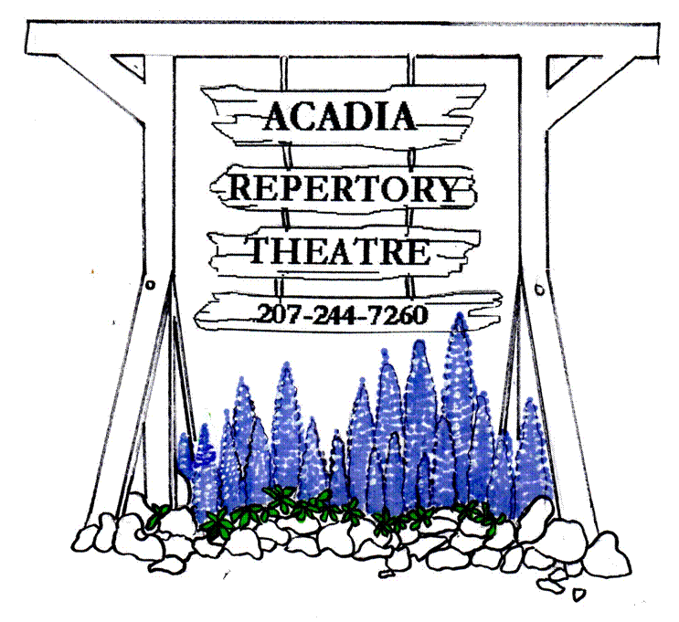
www.acadiarep.com Email: art@acadiarep.com
Live Professional Theatre on Mt. Desert Island
The Lifespan of a Fact
Adapted from the singular book! by Jeremy Karaken & David Murrell and Gordon Farrell
July 6 to July 25
Fully Committed
An Acadia Rep favorite returns! by Becky Mode
July 27 to August 15

DEAR MURDERER
A classic Stage Noir! World-premiere adaptation by Jeffrey Hatcher,
from the play by St. John Legh Clowes
August 17 to September 5
PERFORMANCES: TUESDAY thru SATURDAY EVENINGS at 8:15 PM, SUNDAY MATINEES at 2:00 PM

2021 ~ 48th Summer Season
THE NEXT ACT WILL BEGIN SHORTLY!
Dear friends,
We are thrilled to report that the Acadia Rep will return to stage a Summer Season in 2021!
Planning for a theatre season in these peculiar times strained our powers of prediction. With the crystal ball so cloudy, and with the need for advance planning to hire appropriate Company and staff members, we made the call to go with what we knew about the state of COVID restrictions in the late spring. Even though those restrictions have changed in the intervening time, we are going to stick to our plan in order to make sure everyone feels safe and comfortable returning to the theatre. To that end:

- Our productions will all feature compact casts, with appropriate social distancing on stage. Shows will be one-acts that will run up to an hour and a half long.
- Social distancing will remain in place. Every other row will be blocked off and we will encourage audiences to come in “pods” of people they feel comfortable sitting with.
- Upon arrival, groups will be asked to line up outside the building until they can be welcomed in one group at a time; in case of inclement weather, we will ask that people wait in their cars until a staff member alerts them the house is open.
- Vaccinations and mask usage will be encouraged of our audiences, and required of our staff for the time being. Hand sanitizer and enhanced cleaning protocols will remain in place.
- All our air handling will be utilized to its fullest, and new methods will be installed when possible.

We offer several options for you to subscribe and support the Theatre this year:
- Our classic Patron subscription will remain the same at $425 for 25 tickets, and greater discounts for larger numbers of tickets!
- Our Season Subscriptions will cost $65 for three shows, which is 50% off the third show!
- And any Donations you would care to make beyond that will not only provide us essential support, but may be tax-deductible as a charitable contribution!

Please combine these options as you see fit! Anything you are able to donate is enormously helpful for our work. No donation is too small. And even simply buying tickets is enough, if that’s all you feel you can do! We only survived the plague year of 2020 through the generosity of nearly 100 donors, who gave anything from $10 to $4000 and thereby enabled us to pay the bare minimum so we could still be here in 2021. The awareness that has brought us, of just how many people value the work we do and our presence here on MDI, is profoundly moving to us all at the Theatre. Everyone please stay safe, and we’ll see you soon in Somesville once again!

Andrew, Cheryl, and the Board of Directors of the Acadia Repertory Theatre
ACADIA REPERTORY THEATRE P.O. Box 106, Mt. Desert, ME 04660

\

NAME: _________________________________________________________________
(as you’d like to see it listed in our Program Book and lobby display)

*We only need your address if it has changed since last year!*

ADDRESS: _____________________________________________________________
CITY: _________________________________STATE: _______ ZIP: _____________
E MAIL: ________________________________________
PHONE NUMBER: _______________________________

I/we wish to become a PATRON for the 2021 SUMMER SEASON.

PATRON (25 tickets) $425 (__) PATRON (50 tickets) $600___(__)
PATRON (75 tickets) $900___(__) PATRON (100 tickets) $1200___(__)

Please list me/us as a DONOR for the 2021 SUMMER SEASON.
(Donations may be tax-deductible as contributions to a 501.c.3 charitable organization)
CADILLAC CIRCLE $2000+ (__)
SARGENT CIRCLE $1000+ (__)
DORR CIRCLE $500+ (__)
PEMETIC CIRCLE $100+ (__)
BUBBLES CIRCLE Any amount (__)

ACADIA REPERTORY THEATRE P.O. Box 106, Mt. Desert, ME 04660

Please list me/us as a SUBSCRIBER for the 2021 SUMMER SEASON.

ONE SUBSCRIPTION $65 (__)
TWO SUBSCRIPTIONS $130 (__)
(____) SUBSCRIPTIONS @$65 each (_______)
ADDITIONAL DONATION Any amount (_______)
(Donations may be tax-deductible as contributions to a 501.c.3 charitable organization)

NAME: _________________________________________________________________

*We only need your address if it has changed since last year!*

ADDRESS: _____________________________________________________________
CITY: _________________________________STATE: _______ ZIP: _____________
EMAIL: ________________________________________
PHONE NUMBER: _______________________________

